Lab – Module 5

Shaun Pritchard

Rasmussen College

CDA3315C

Alan Dennis

July,23 2020

Lab – Module 5

**Module-1** – completed full project scope and all specification of the assigned enterprise architecture web application.

**Full web application and its updates can be found here:**

<https://enterprisearchitecturewebapp.azurewebsites.net>

**Module 2 -** In this lab I updated the interface to pull out the active database tables and display them in the web application. I also added a new column to display the current database table that all the submissions are stored in, and I added a delete function to unregister a user. See screenshots below in *Lab Module 2 section.*

**Module-3** - In this lab I have updated the database CRUD functionality and to create a READ function that displays all the active database inventory through an alert action display popup to view current submissions. I am also working on the logic to show the users data who have been deleted from the inventory registry as well. Shown below in **Fig:3-1**.

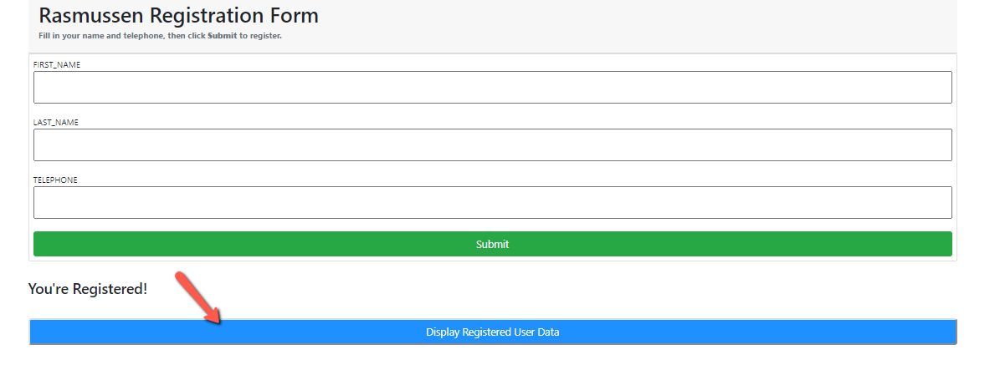 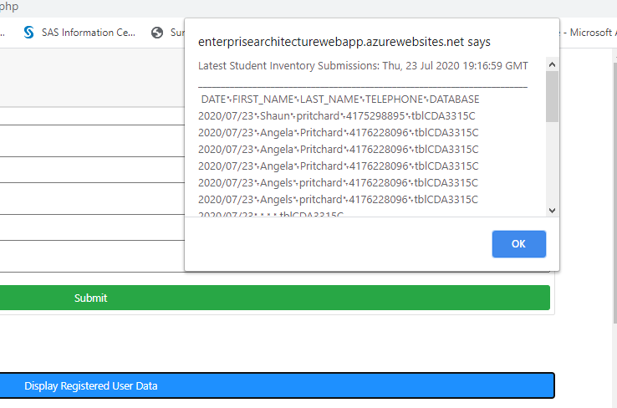

**Fig:3-1:** Added READ functionality and alert to display invintory data on click event.

**Module-4** Develop scripting to update and change submitted data in the inventory application

**Module-5** finish updating PUT functionality to the initial CRUD application is complete it can read, write, update, and delete information in the DB and frontend. Here is the finished interface.

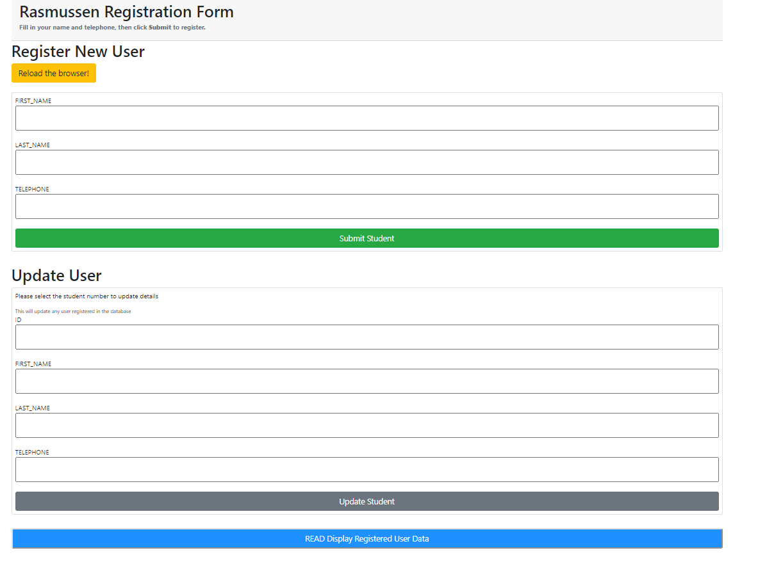

Update registered student:

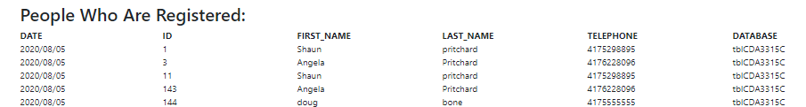

**Lab- Module 1:**

1. **Logged in to student cloud portal system.**

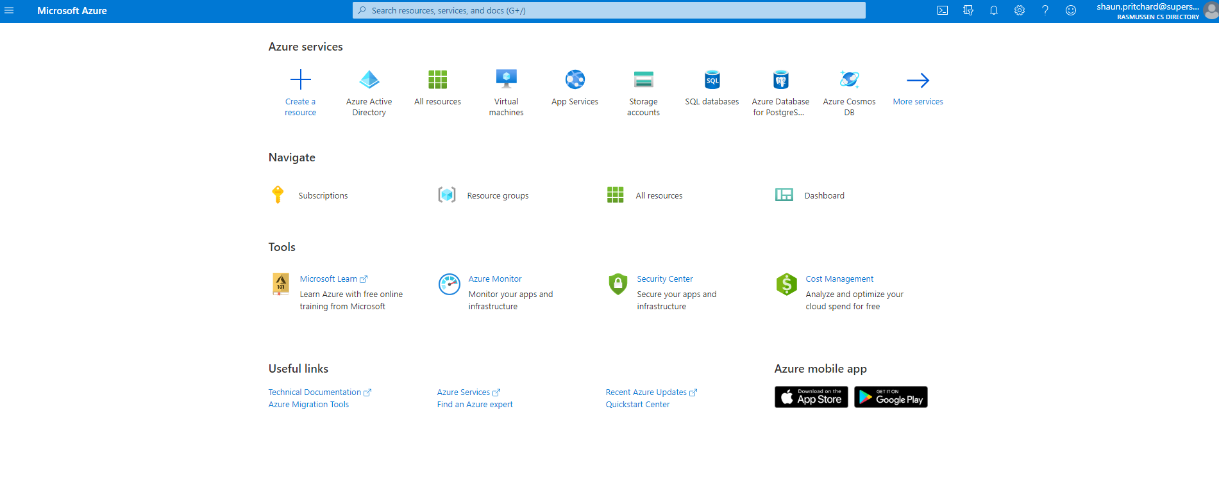

1. **Created a new Web App + MySQL service on Azure.**

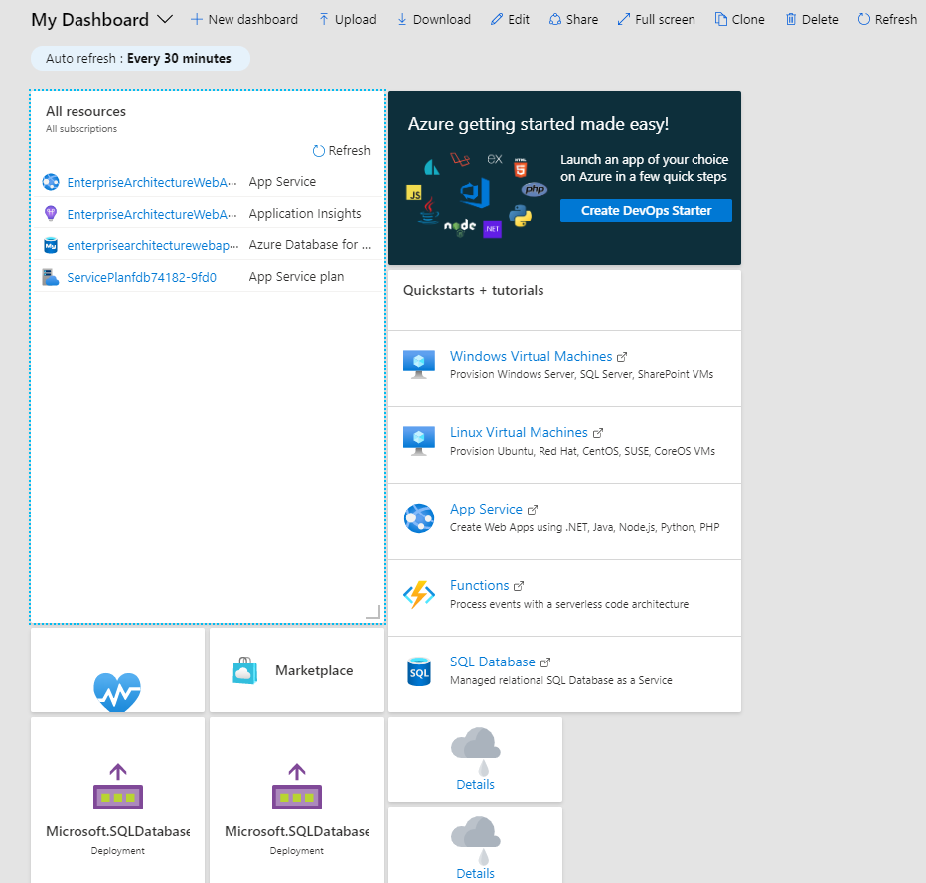

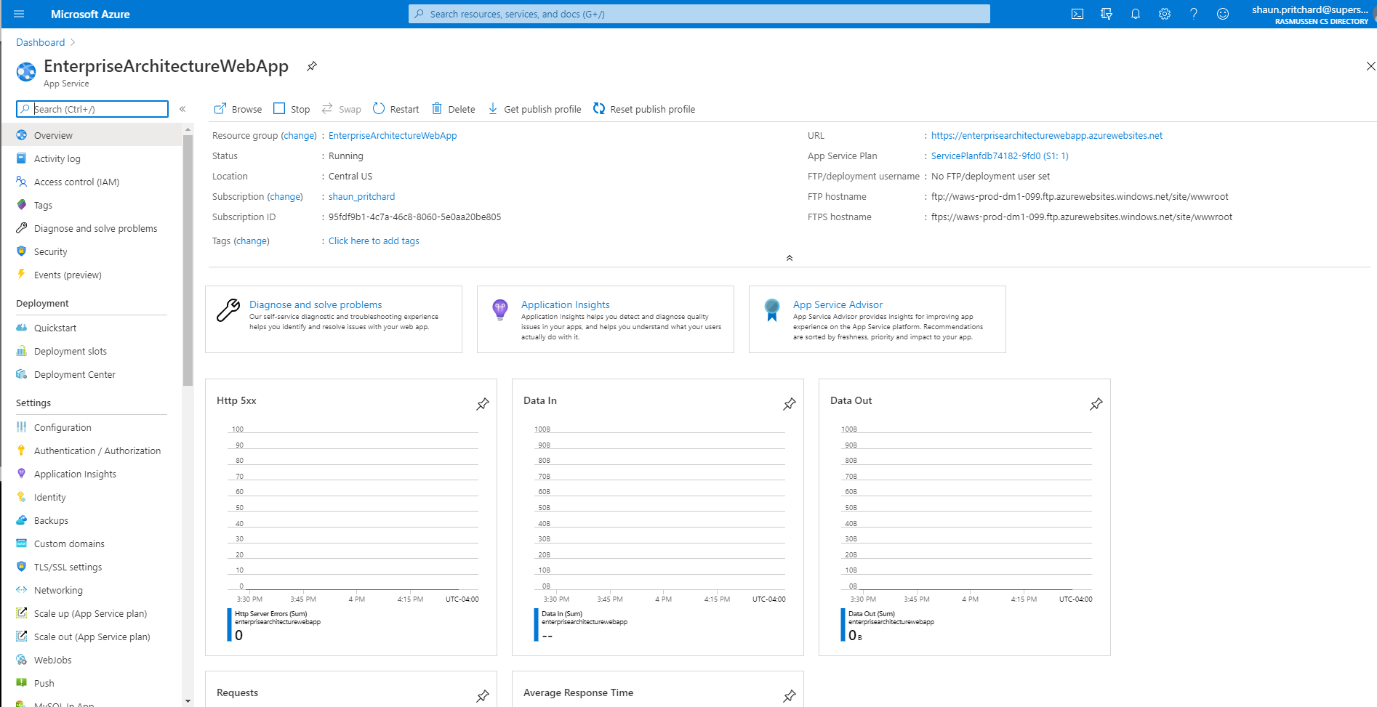

1. **Create a new MySQL database service.**

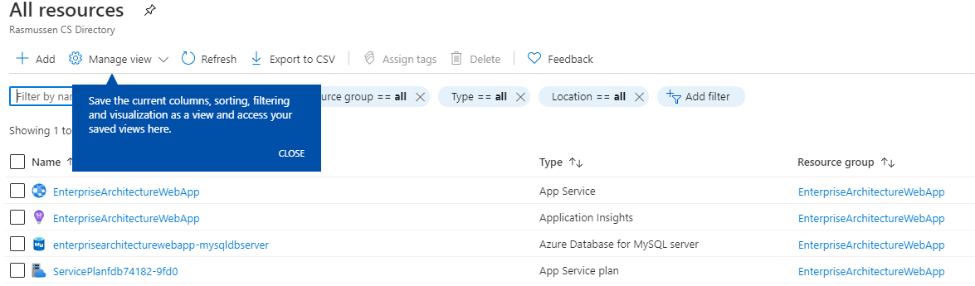

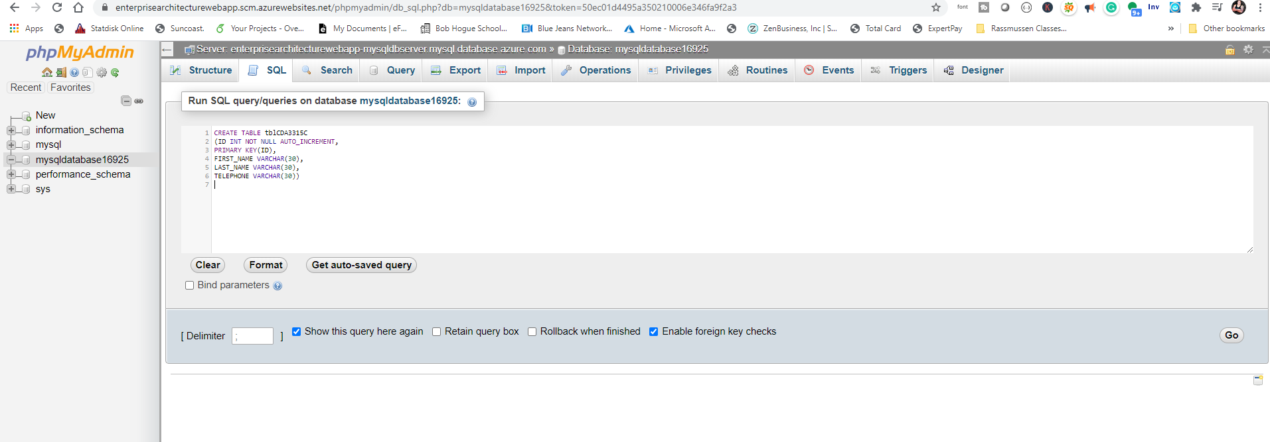

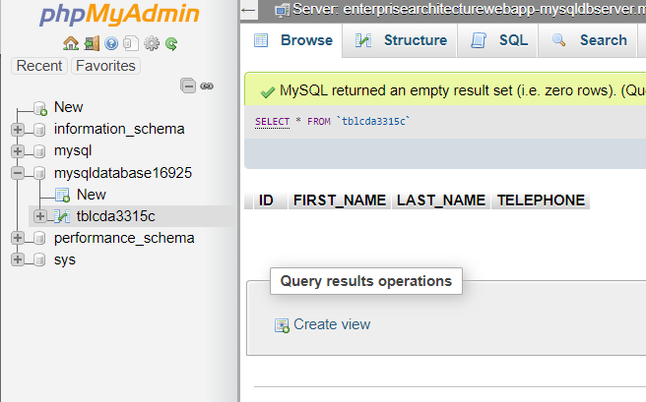

1. **Create a new Web App service connection string.**

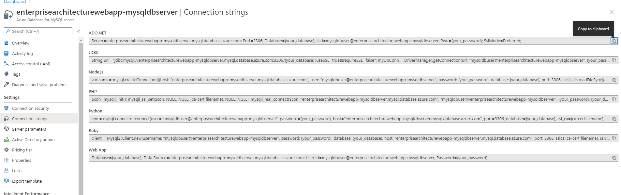

1. **Create a new Web App service phpMyAdmin extension.**

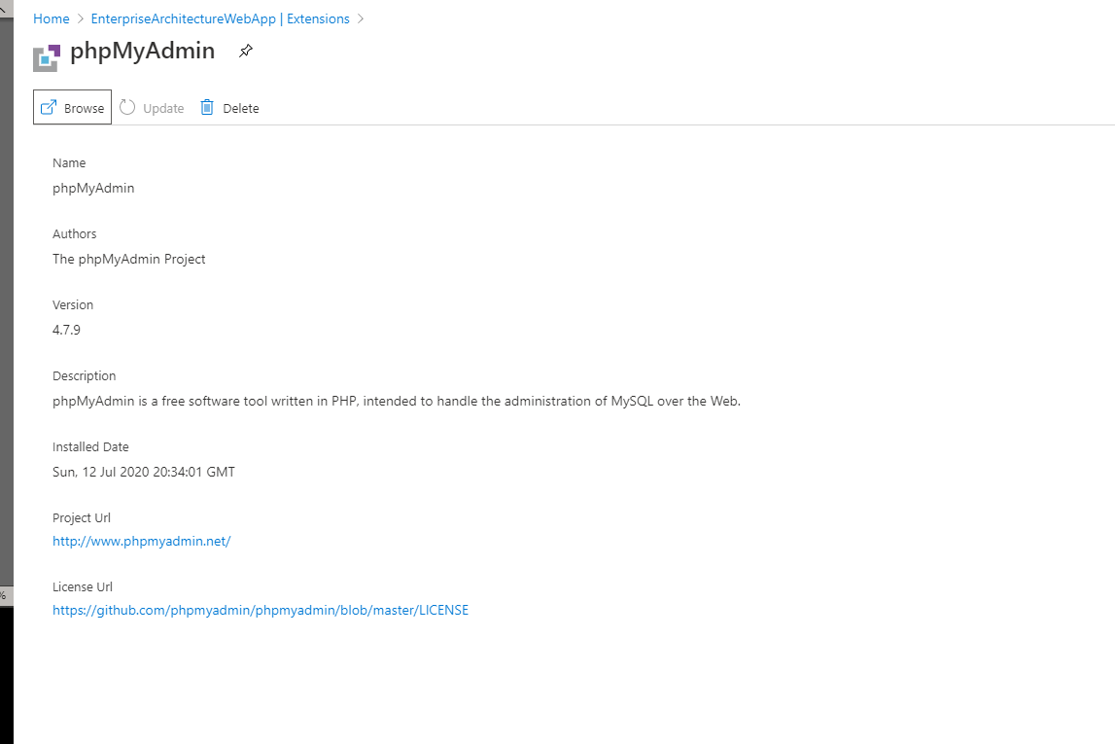

1. **Created PHP service and launched PHP my Admin**

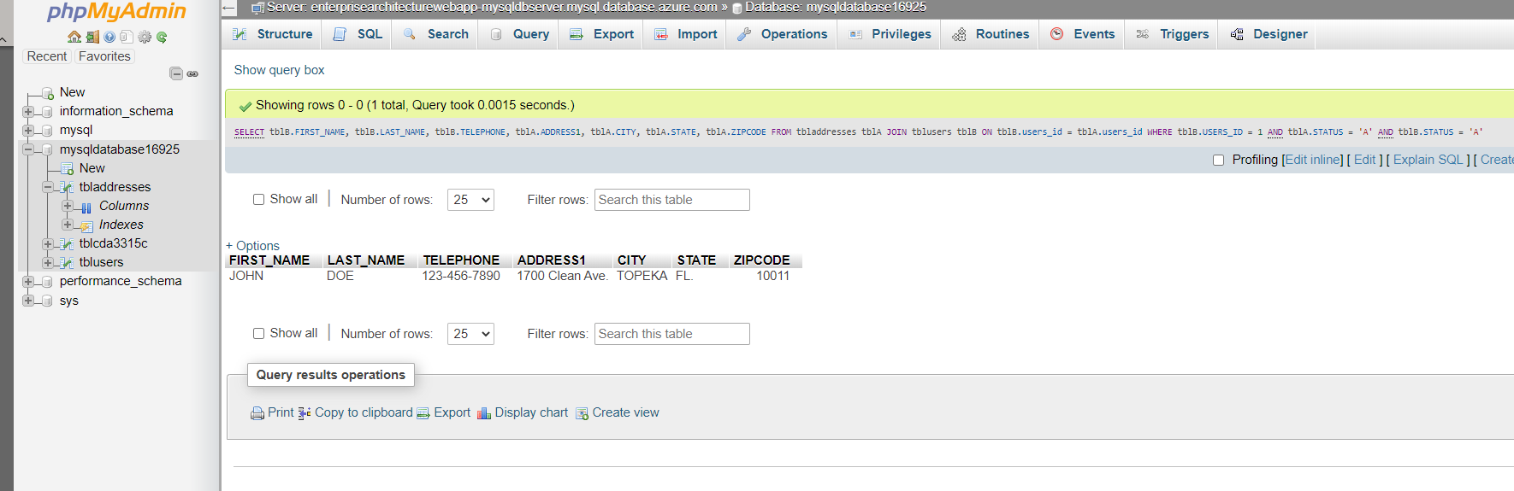

1. **Create Index.php frontend**

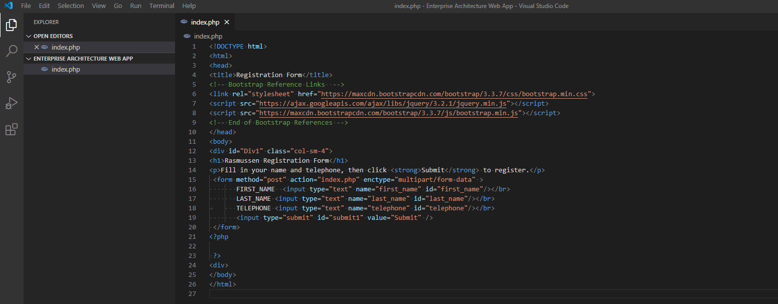

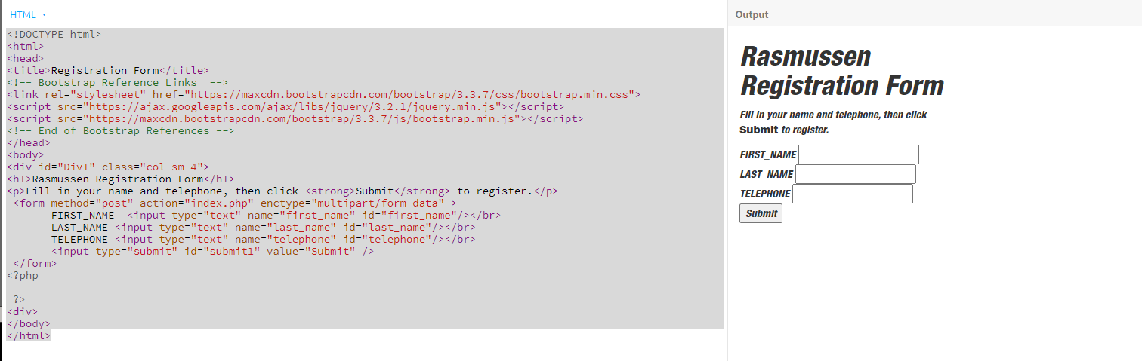

1. **Login to the new phpMyAdmin web app.**

**I had some issues with the inline CSS, so I had to repair it to the best of my knowledge using bootstrap and raw CSS It is responsive now see below.**

**Issues from CSS:**

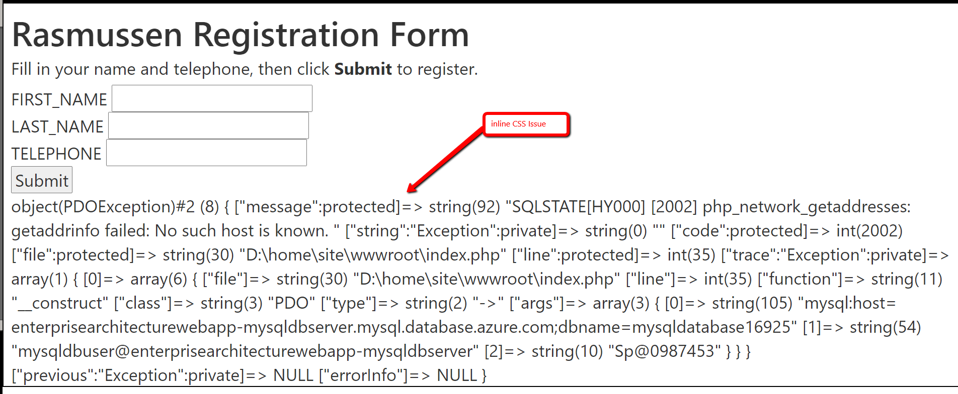

1. **Using FTP to load finished Web App:**

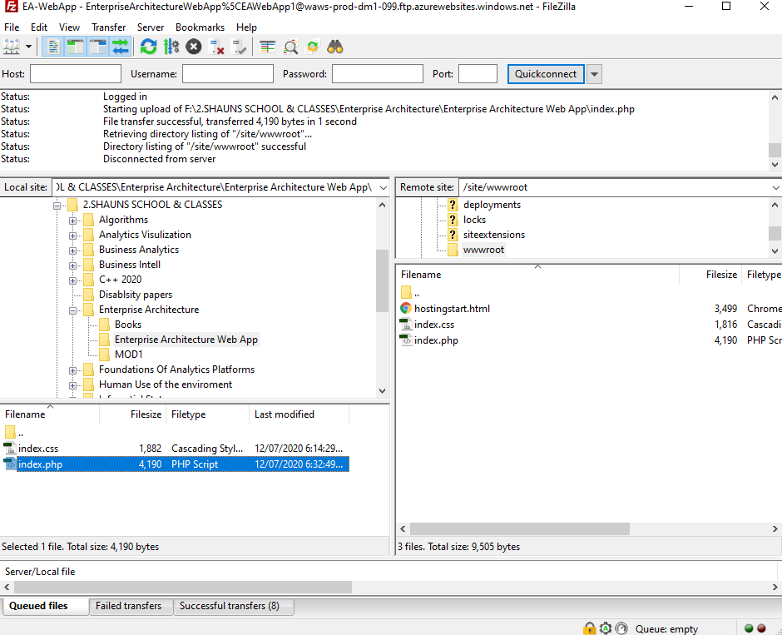

**10.Finished responsive Web App with 6 submit to DB styled by me:**

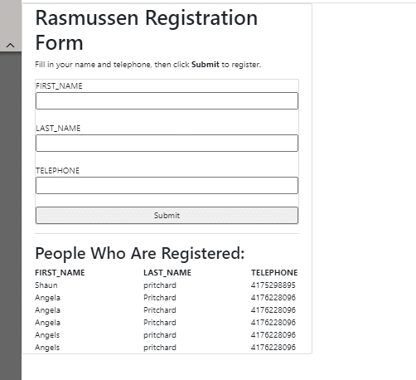

1. **Responsive version**

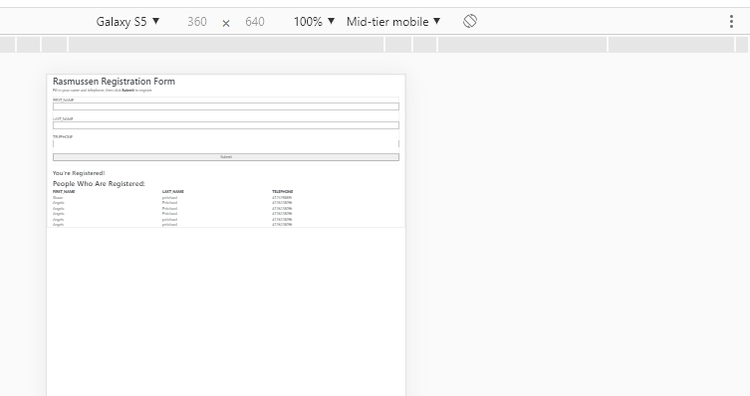

1. Here is with the original inline CSS style. It did not seem to scale correctly.

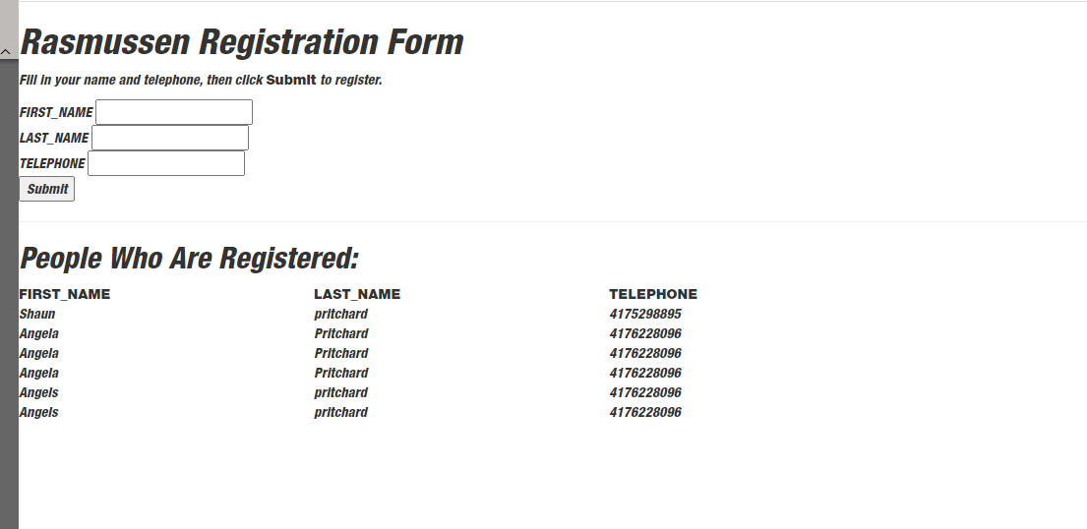

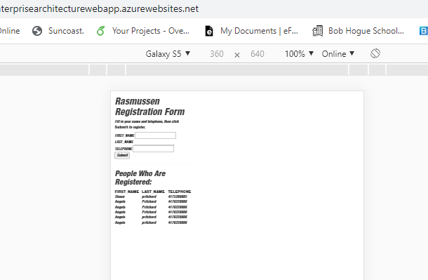

**Finished…**

**Lab- Module 2:**

1. **Updated style of user registration form centered column and made fully mobile responsive.**

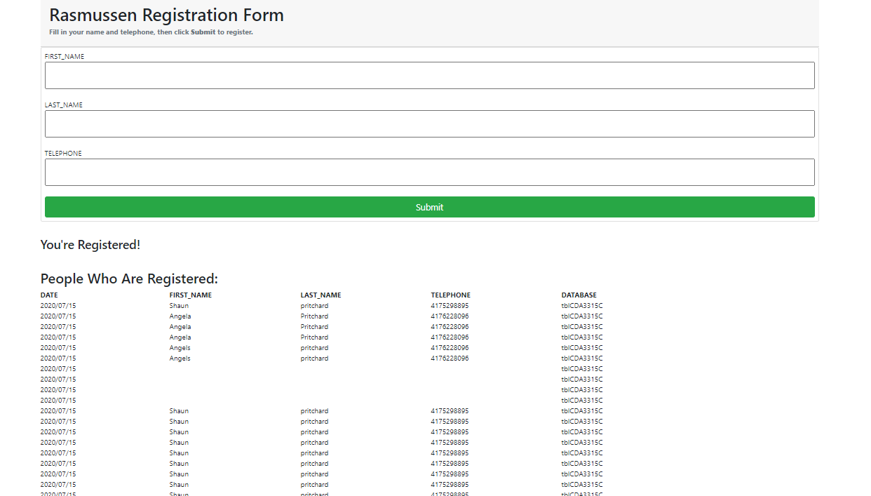

1. **Added 5th column to display the database table name of saved registered users**



1. **Added functionality to pull out all database table names programmatically using PHP and display them in the web Application.**

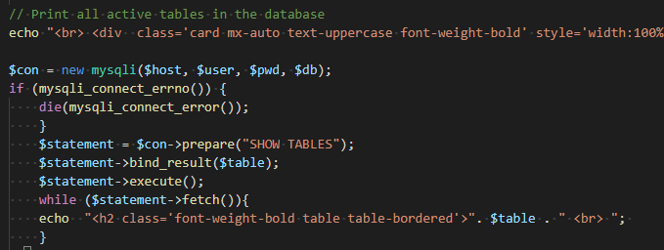

1. **Added delete functionality to remove a user row from the submission list.**

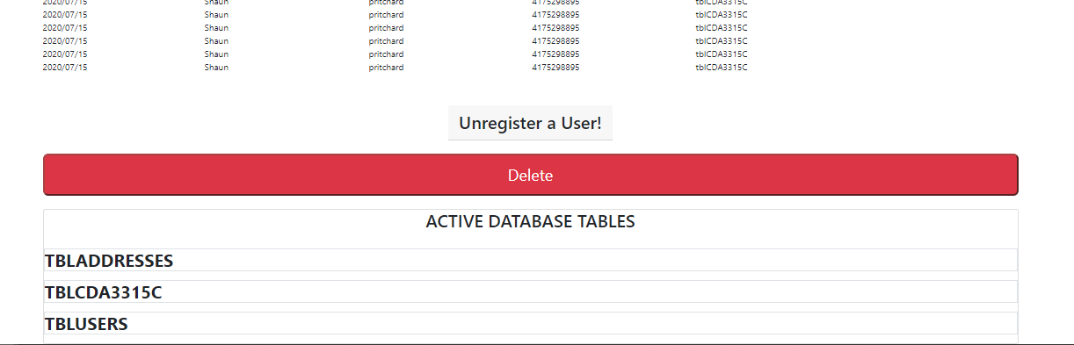

1. **Can delete users from submission list.**

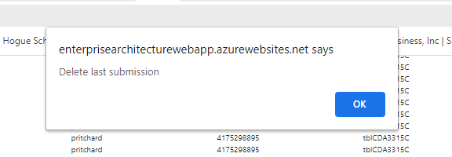

**Record with user Shaun:**



**Removed record of user Shaun:**



1. **Is mobile responsive and improved**

